Assignment 6  
Exercise 1: Unix Text Analysis

1. Setting up the Virtual Machine on VMWare Fusion, with Centos7 operating system.
2. Completed downloading essential files including “The Raven.txt” file.

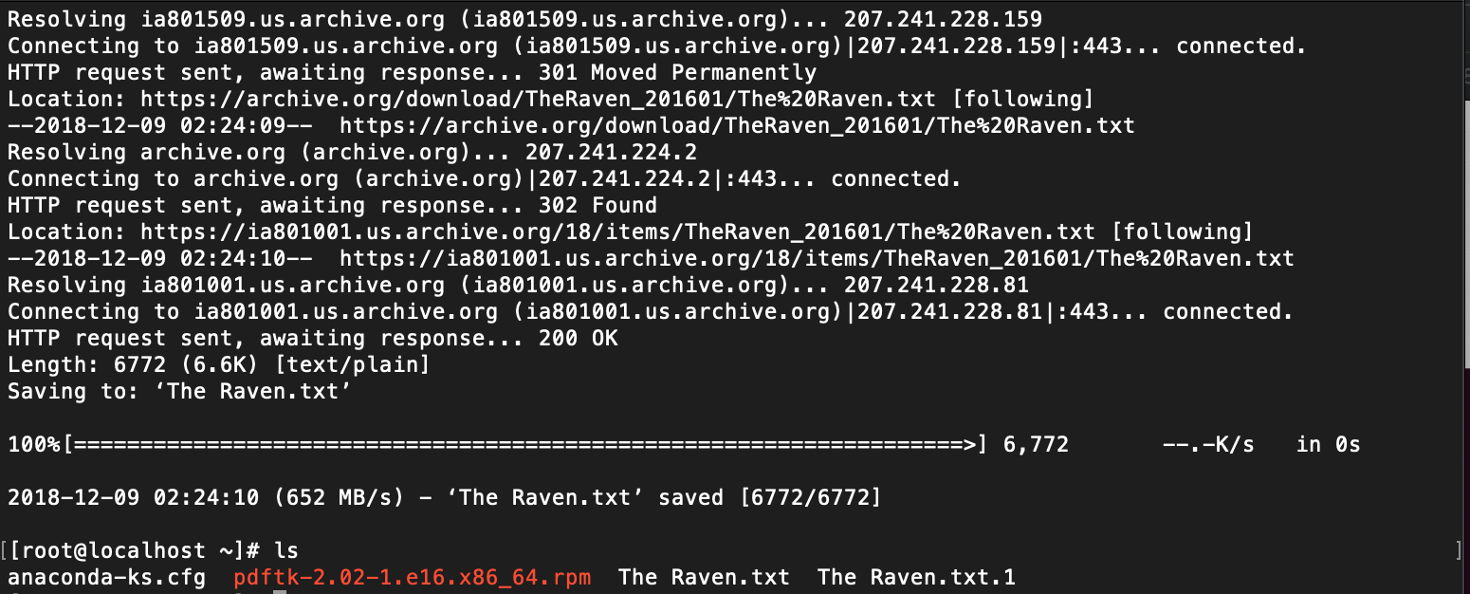

1. Using the *head* and *tail* commands to view the content of the text file

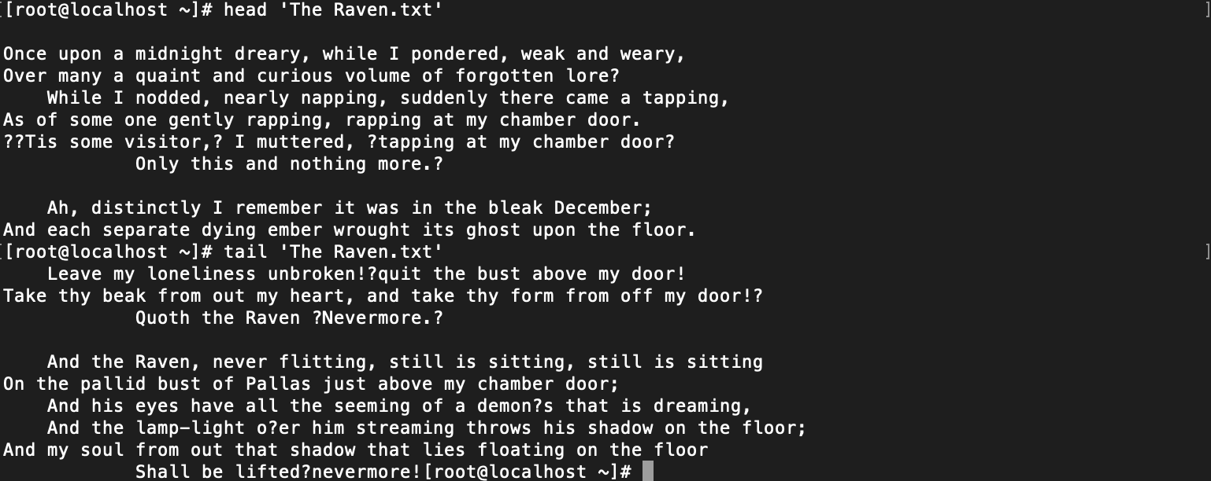

1. Using the *less –N* command to view the content of the file in a pop-up-window like manner.

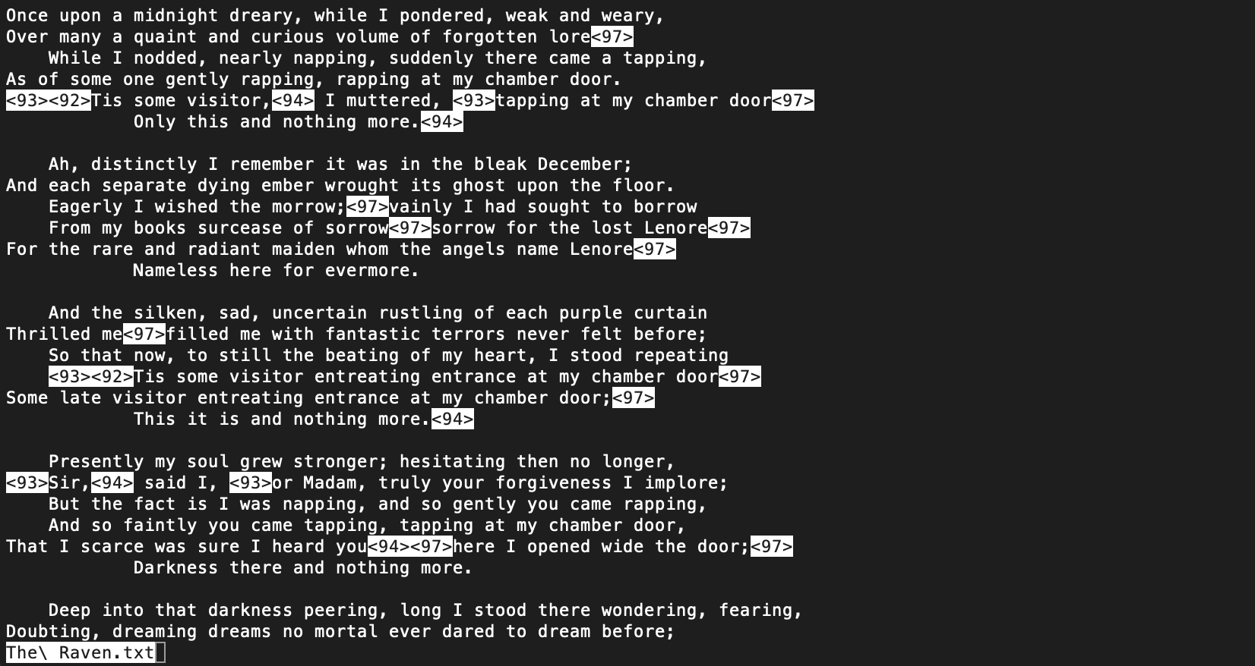

1. “The Raven.txt” file was giving me difficulty due to its space. Therefore, I copied it to “theraven_orig.txt” and continued to work on this new file.

I performed some deleting of lines using the *sed* command as well.

1. Word counts using  *wc –l* and *wc –m* commands.



1. Searing for words/phrases using *grep* and using *–n* commands to display results with line number.



1. Searching for words/phrases without case sensitivity using the *grep –E –n* command.

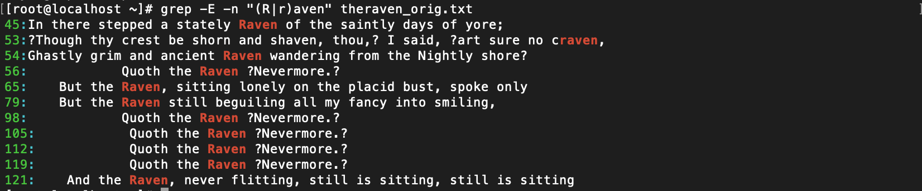

1. Deleting, finding and replacing of characters from the txt file using *tr –d [:punct:]* to delete punctuations, *tr [:upper:] [:lower:]* commands for convert all text to lowercase.



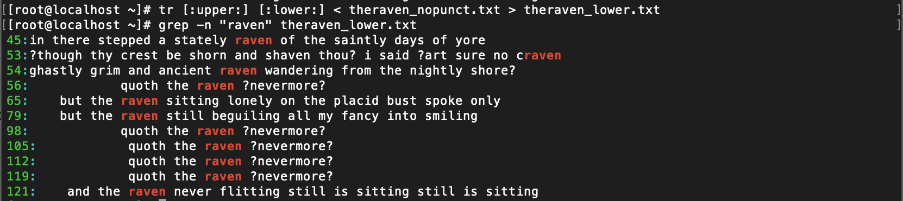

1. Using *tr –d ‘\r’* command to remove false carriage return characters;

Using *tr ‘ ‘ ‘\n’* to delete blank spaces  
Using *sort* command to sort the words in the text file.

Using *uniq –c* command to count numbers of repetitions.

Finally, using the *head* and *tail* commands, the final file (theraven_wordfreq.txt) displays the results of the counts.

